LEARNING QUIZ AGENT
Capstone Deliverables
Five artifacts that demonstrate enterprise architecture completeness
Student: Divya Shree K (2023103058)
Course: Scalable Enterprise Architectural Deployments of Agentic AI Solutions

Overview
This document presents the five capstone deliverables for the Learning Quiz Agent, a web application that generates quizzes, evaluates student answers, analyzes performance and recommends study plans.
# | Deliverable | Scope
1 | Architecture Diagram | Layers, components, trust boundaries and integrations
2 | Agent Workflow Design | Roles, states, tools, handoffs, approvals and failure paths
3 | Deployment Strategy | Runtime, scaling, resilience, environments and release
4 | Security Model | Identity, authorization, secrets, privacy, guardrails and audit
5 | Monitoring Dashboard Design | Health, trace, quality, safety, cost and business outcomes

1. Architecture Diagram
The Learning Quiz Agent is organized into four main architectural layers, from the user-facing interface down to the build and hosting pipeline. This section describes the layers, their components, the trust boundaries between them and the integrations the system relies on.

Layers
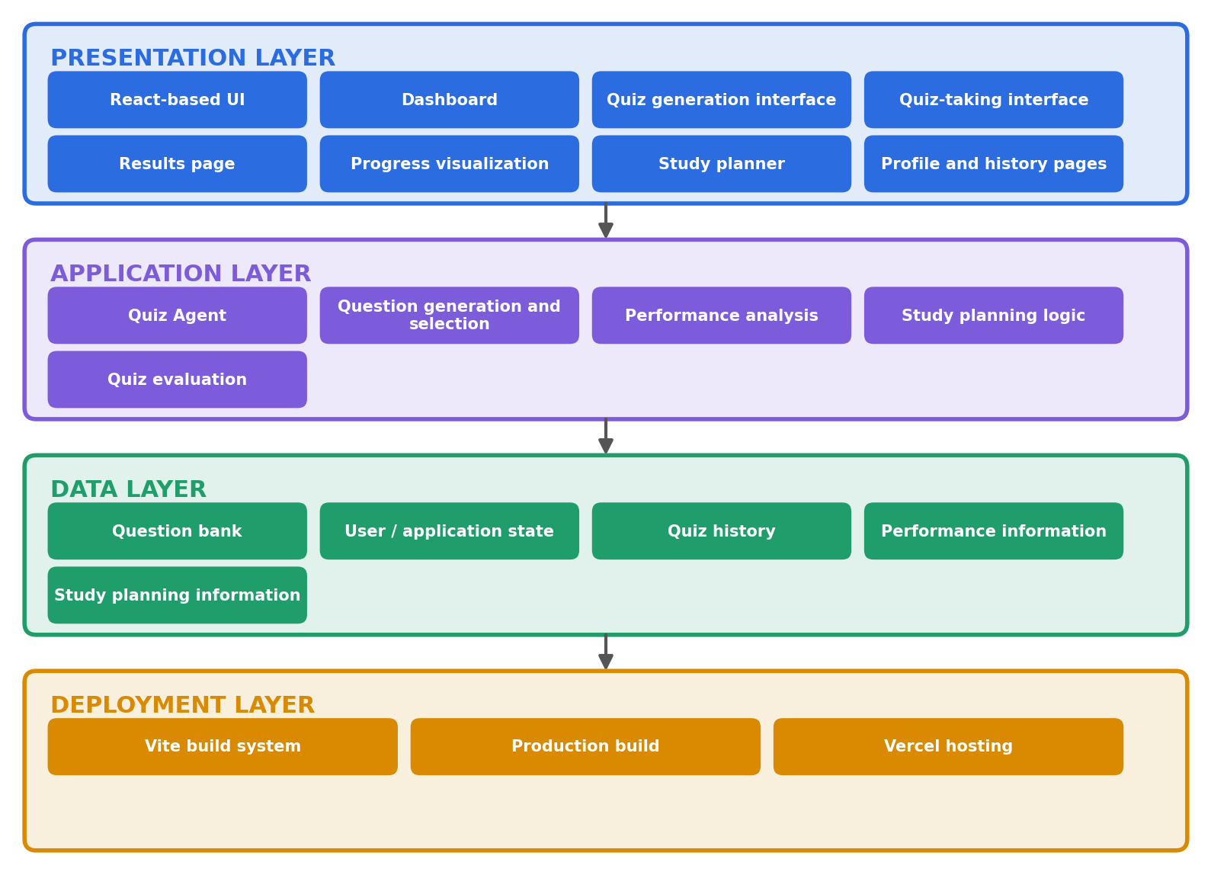
Figure 1: Main architectural layers
Presentation Layer | - React-based user interface  - Dashboard  - Quiz generation interface  - Quiz-taking interface  - Results page  - Progress visualization  - Study planner  - Profile and history pages
Application Layer | - Quiz Agent  - Question generation and selection  - Performance analysis  - Study planning logic  - Quiz evaluation
Data Layer | - Question bank  - User/application state  - Quiz history  - Performance information  - Study planning information
Deployment Layer | - Vite build system  - Production build  - Vercel hosting

Components
The layers are realized by the following application components, organized under the src/ folder of the repository.
Component | Module | Responsibility
User interface | src/pages/, src/components/ | Dashboard, quiz generation, quiz-taking, results, progress, study planner, and profile and history pages
Navigation | src/App.tsx, src/nav.tsx | Page routing and access to application features
Quiz Agent | src/agent/ | Question generation and selection, quiz evaluation and performance analysis
Question bank | src/questionBank.ts | Source of questions used by the agent
Study planner | src/studyPlanner.ts | Study planning logic and recommendations
Application state | src/context.tsx | Shared user and application state across pages
Persistence | src/storage.ts | Storage and retrieval of quiz history, performance and study plan data
Data models | src/types.ts | Shared type definitions for quizzes, results and plans

Trust Boundaries
Trust boundaries mark the points where data or control passes between zones with different levels of trust. Each boundary has a control that must be applied before data is accepted.
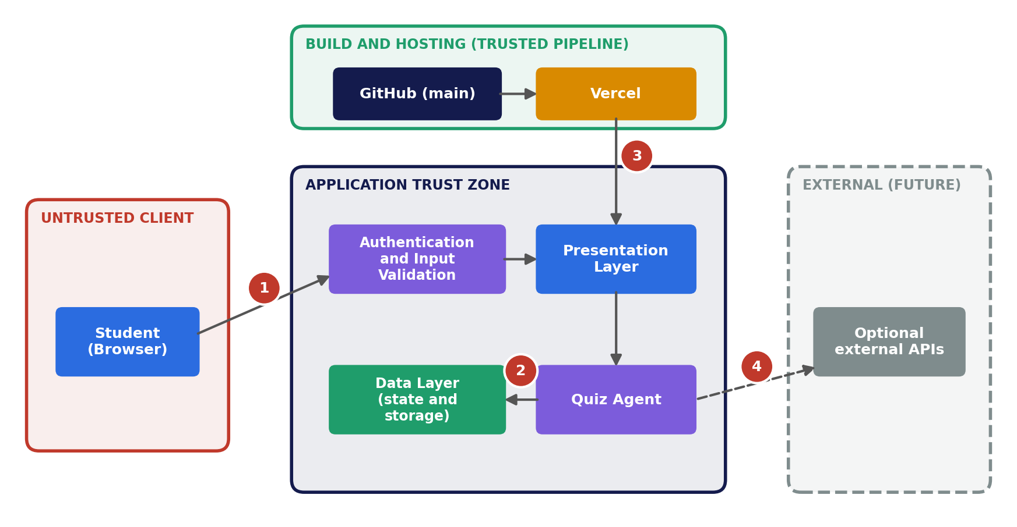
Figure 2: Trust boundaries
# | Boundary | What crosses it | Control
1 | Student browser to application | Learning requirements, quiz answers and login details entered by the student | Authentication and input validation before any processing
2 | Application logic to data layer | Quiz history, performance data and study plan data | Access only through the application's state and storage modules; previously saved data is preserved on failure
3 | Build pipeline to production | Source code and production build | Deployment only from the main branch; secrets and .env files kept out of the repository
4 | Application to external services (future) | Requests to any external API added later | Credentials held in environment variables; responses validated before use

Integrations
Integration | Type | Purpose
GitHub | Source control | Stores the source code and version history, and acts as the source for deployments
Vercel | Hosting and delivery | Builds the application with npm run build and serves the dist output to students
Vite | Build tooling | Bundles the React and TypeScript code into an optimized production build
Student browser | Client runtime | Runs the interface and agent logic, and holds application state
External APIs (future) | Optional service | Any future question-generation or learning service, connected through environment-variable credentials

2. Agent Workflow Design

Learning Quiz Agent Workflow
The workflow begins when a student starts a learning session and ends when the student continues learning with updated progress and a refreshed study plan.
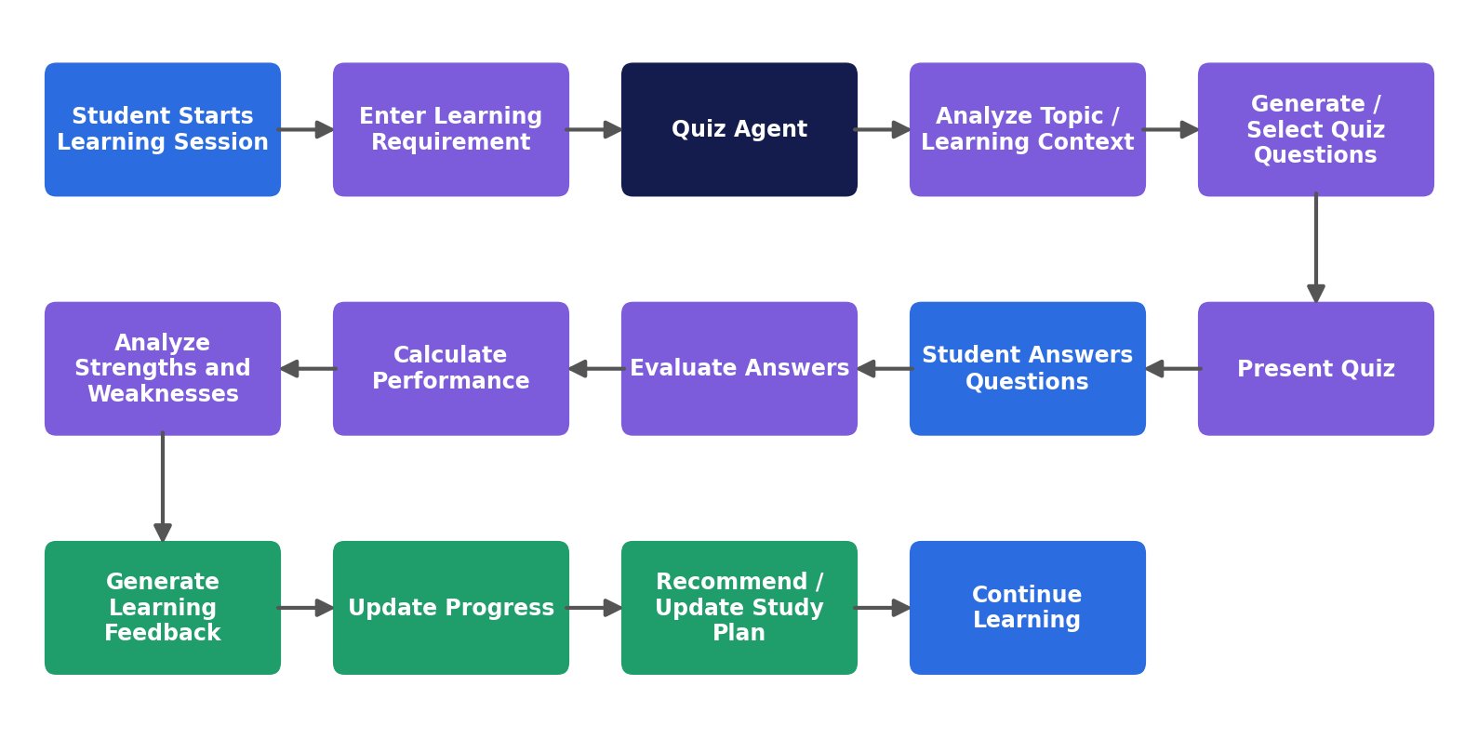
Figure 3: Learning Quiz Agent workflow

Roles
Role | Type | Responsibility
Student | Human user | Provides the learning requirement, answers quiz questions, reviews feedback and acts on the study plan
Learning Quiz Agent | Application agent | Analyzes the requirement, selects or generates questions, evaluates answers, analyzes performance and prepares study recommendations
Web application | System | Presents the interface, validates input, maintains state and stores learning data
Maintainer | Human operator | Maintains the question bank and application code, and releases updates

Agent Responsibilities
The Learning Quiz Agent supports the following activities:
- Understand the student's quiz requirement.
- Select or generate suitable questions.
- Present questions in an interactive format.
- Evaluate submitted answers.
- Calculate quiz performance.
- Identify strong and weak areas.
- Provide learning feedback.
- Maintain quiz history.
- Support study planning.
- Track learning progress.

Agent States
State | Description
Input | Student provides learning requirement
Analysis | Requirement and topic are analyzed
Question Generation | Questions are prepared
Quiz | Questions are presented
Evaluation | Answers are evaluated
Analysis | Performance is analyzed
Feedback | Learning feedback is presented
Planning | Study recommendations are prepared
Completed | Learning session is stored

Tools
The agent works only with tools inside the application. It does not call external systems.
Tool | Module | Used for
Question bank | src/questionBank.ts | Selecting questions that match the learning requirement
Evaluation and analysis logic | src/agent/ | Scoring answers and identifying strong and weak areas
Study planner | src/studyPlanner.ts | Generating and updating study recommendations
Storage | src/storage.ts | Saving quiz history, performance data and plans
Application state | src/context.tsx | Sharing session state across pages

Handoffs
# | From | To | Handoff
1 | Student | Quiz Agent | Learning requirement is submitted through the quiz generation interface
2 | Quiz Agent | Student | Prepared questions are presented in the quiz-taking interface
3 | Student | Quiz Agent | Completed answers are submitted for evaluation
4 | Quiz Agent | Data layer | Results, performance information and history are stored
5 | Quiz Agent | Student | Feedback, progress and study recommendations are presented

Approvals
The agent takes no actions outside the application, so approvals are student-driven checkpoints within the workflow.
Checkpoint | Approver | Purpose
Requirement submission | Student | Quiz generation starts only after the student submits a valid requirement
Quiz submission | Student | Answers are evaluated only after the student submits; invalid submissions are blocked
Study plan | Student | Recommendations are advisory; the student decides whether to follow or update the plan
Release of changes | Maintainer | Code and question bank changes reach production only when merged to the main branch

Failure Paths
If a quiz operation cannot be completed:
- Validate the provided input.
- Display an understandable message to the student.
- Prevent invalid quiz submission.
- Preserve previously available learning data.
- Allow the student to retry the operation.
Each failure path returns the workflow to a safe state: the student sees a clear message, existing data is untouched, and the session can restart from the Input state.

3. Deployment Strategy

Deployment Architecture
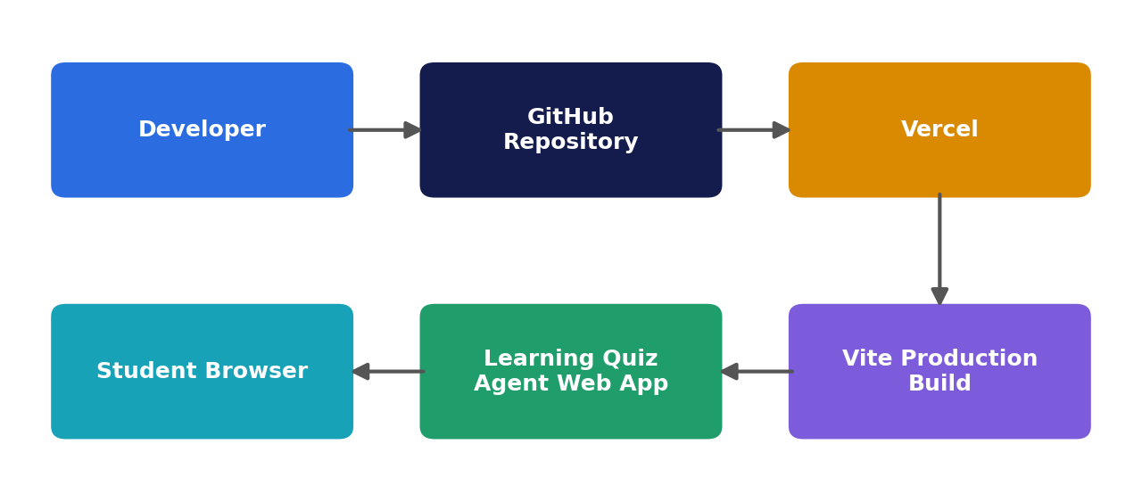
Figure 4: Deployment pipeline

Runtime
The application is a single-page web application built with Vite. The production build is a set of static assets that Vercel serves to the student's browser, where the interface and agent logic run. No application server needs to be provisioned or managed.

Scaling
- Static assets are delivered through Vercel's hosting platform, so additional students do not require additional servers to be configured.
- Quiz logic runs in each student's own browser, so computation grows with the number of users rather than loading a central server.
- If a server-side service or external API is added later, it should be sized and rate-limited separately.

Resilience
- No single application server is involved in serving the application.
- Every release is tied to a GitHub commit, so a faulty change can be reverted and redeployed.
- Vercel retains previous deployments, which supports rolling back to the last working version.
- Failures in quiz operations preserve existing learning data and allow the student to retry.

Environments
Environment | Source | Purpose
Local development | Developer machine, Vite development server | Building and testing changes before they are committed
Preview | Non-main branches deployed by Vercel | Reviewing changes at a separate URL before release
Production | main branch deployed by Vercel | The live application used by students

Release
- Developer commits changes to the GitHub repository.
- Changes are pushed to the main branch.
- Vercel detects the change and runs npm run build in the root directory.
- The Vite production build is written to the dist folder.
- Vercel publishes the build as the live application.
- If a problem is found, the previous deployment is restored or the change is reverted and redeployed.

Source Repository
GitHub Repository:
https://github.com/DivyaShreeK-dev/Learning-Quiz-Agent

Repository Structure
Learning-Quiz-Agent/
│
└── 2023103058-DIVYA SHREE K/
│
├── generation-prompt.md
├── Deliverables.md
├── package.json
├── package-lock.json
├── index.html
├── vite.config.ts
├── tsconfig.json
├── tsconfig.app.json
├── tsconfig.node.json
│
└── src/
├── agent/
├── components/
├── pages/
├── App.tsx
├── context.tsx
├── nav.tsx
├── questionBank.ts
├── storage.ts
├── studyPlanner.ts
└── types.ts

Technology Stack
- React
- TypeScript
- Vite
- HTML
- CSS
- JavaScript
- GitHub
- Vercel

Production Deployment
The application is deployed using Vercel.
Live Application:
https://learning-quiz-agent-pgfuwlfpf-divya-62fd.vercel.app/

Deployment Configuration
Configuration | Value
Repository | Learning-Quiz-Agent
Branch | main
Root Directory | 2023103058-DIVYA SHREE K
Framework | Vite
Build Command | npm run build
Output Directory | dist

4. Security Model

Security Architecture
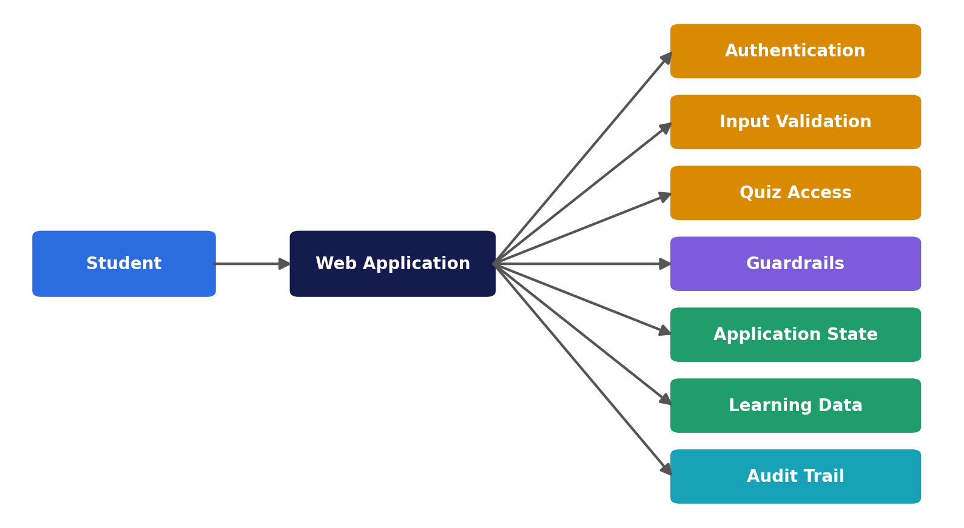
Figure 5: Security architecture

Security Controls

Identity and Authentication
The application provides an authentication interface for users before accessing the learning features.

Authorization
Application pages and learning functionality are controlled through the application's authentication and navigation flow.

Input Validation
User-provided learning requirements and quiz inputs should be validated before processing.

Data Protection
Sensitive configuration values should not be stored directly in source code. Environment variables should be used for any future external API keys or service credentials.

Secret Management
The following files must not be committed to GitHub:
- .env
- .env.local
The project .gitignore excludes environment files and generated dependencies.

Dependency Security
Dependencies are managed through:
- package.json
- package-lock.json
Generated dependency folders such as node_modules are excluded from source control.

Privacy
Only information required for application functionality should be collected and stored.

Guardrails
Guardrails keep the agent within its intended purpose and prevent unsafe or invalid operations:
- Input is validated before a quiz is generated or evaluated.
- Invalid quiz submissions are blocked.
- The agent is limited to quiz generation, evaluation, performance analysis and study planning inside the application, with no access to external systems.
- Questions are drawn from the application's question bank.
- Error messages are understandable and do not expose internal details.
- Previously saved learning data is preserved when an operation fails.
- If external services are added later, their responses should be validated and their usage limited before use.

Audit
Audit records make it possible to see what happened, when and who was responsible:
- Quiz history and performance information record each completed learning session and its outcome.
- The GitHub commit history records every change to the source code, including the question bank.
- Vercel deployment history records each release and its source commit.
- Authentication failures, failed operations and unexpected errors should be recorded with a time and reviewed through the monitoring dashboard.

5. Monitoring Dashboard Design

Monitoring Overview
The monitoring dashboard is designed around seven dimensions: health, trace, quality, safety, usage, cost and outcomes.
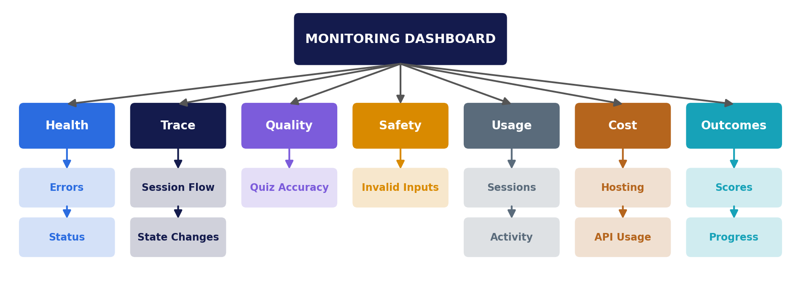
Figure 6: Monitoring dashboard dimensions

Key Monitoring Metrics

Application Health
- Application availability
- Page loading status
- Runtime errors
- Deployment status

Trace
Trace shows how an individual learning session moved through the agent workflow:
- Session flow across the agent states, from Input to Completed
- Success or failure of each state transition
- Questions presented and answers submitted in a session
- Failed operations linked to the state in which they occurred
- Build and deployment logs linked to the source commit

Quiz Quality
- Number of quizzes completed
- Question completion rate
- Answer accuracy
- Average quiz score

Learning Progress
- Student performance over time
- Strong topics
- Weak topics
- Quiz history
- Study plan completion

Safety and Reliability
- Invalid input attempts
- Failed operations
- Authentication failures
- Unexpected application errors

Cost
- Hosting usage on Vercel, such as bandwidth and build activity
- Deployment frequency
- Usage of any external service added later, such as the number of API calls
- Cost per completed quiz session

User Outcomes
- Quiz scores
- Performance trends
- Learning progress
- Study activity

Dashboard Components
Component | Purpose
Performance Chart | Visualizes learning performance
Quiz History | Displays previous quiz activity
Progress View | Tracks learning progress
Study Planner | Organizes future learning activities
Results View | Displays quiz results
Agent Activity | Shows agent-related activity
Trace View | Shows the path of a learning session through the agent states
Cost Summary | Shows hosting and service usage against expectations

Coverage Summary
The table below shows where each element of the capstone deliverables slide is addressed in this document.
Deliverable | Slide scope | Where addressed
1. Architecture Diagram | Layers, components, trust boundaries and integrations | Layers; Components; Trust Boundaries; Integrations
2. Agent Workflow Design | Roles, states, tools, handoffs, approvals and failure paths | Roles; Agent States; Tools; Handoffs; Approvals; Failure Paths
3. Deployment Strategy | Runtime, scaling, resilience, environments and release | Runtime; Scaling; Resilience; Environments; Release
4. Security Model | Identity, authorization, secrets, privacy, guardrails and audit | Identity and Authentication; Authorization; Secret Management; Privacy; Guardrails; Audit
5. Monitoring Dashboard Design | Health, trace, quality, safety, cost and business outcomes | Application Health; Trace; Quiz Quality; Safety and Reliability; Cost; User Outcomes

